[](https://classroomclipart.com/clipart/Clipart/Science.htm)



# Georgia’s Youth Targeting Tomorrow

STARBASE ROBINS Summer Registration Form

**Participant Information:**

Student First Name: _______________________________

Student Last Name: _______________________________

Grade entering Aug 2020 _________ Name of School: ___________________________________

(Please include city and state of school)

Parent/Guardian Name: ____________________________________________________________

Parent/Guardian E-Mail Address and Emergency Contact phone number:

**E-Mail address your student will be using for the program:**

________________________________________________________________________________

Mailing Address: ________________________________________________________________

______________________________________________________________

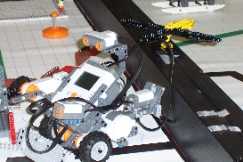

Activities your student would be interested in:

________________________________________________________________

Please e-mail completed form to [martha@starbaserobins.org](mailto:martha@starbaserobins.org).

You will receive a confirmation of your registration and at that time, your seat is guaranteed.

You will receive log in information for the program.