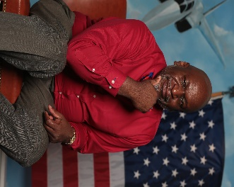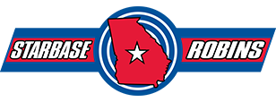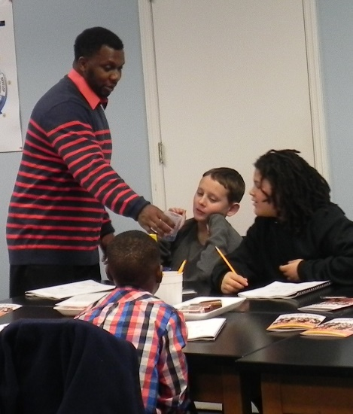

## **2020 Fall Winter issue**

**Website**

[www.starbaserobins.org](http://www.starbaserobins.org)

**Contact Us @**

[info@starbaserobins.org](mailto:info@starbaserobins.org)

**Mailing Address**

Museum of Aviation

P.O. Box 2469

Warner Robins, GA 31099

**Physical Address**

Century of Flight Hangar

1942 Heritage Boulevard

Warner Robins, GA 31098

**Office Contact Numbers**

STARBASE ROBINS Office#

478.926.1769

**Fall/Winter 2020 Issue**

**About STARBASE ROBINS**

STARBASE ROBINS

*offers a hands-on Science, Technology, Engineering, and Mathematics (S.T.E.M.) curriculum to students from local school systems as well as several area private schools. STARBASE ROBINS is a Department of Defense (DoD) educational program sponsored through a partnership with the Air Force Reserve Command (AFRC), the Museum of Aviation, and the Museum of Aviation Foundation, Inc. STARBASE ROBINS emphasizes the importance of goal-setting, teamwork, and communication in everyday life.*

**Page 1**

**Fall/Winter Issue 2020**

**Director's Corner**

## **Wesley Fondal, Jr., Executive Director**

I hope during this time of Covid19 that all is well. We have been very busy since the summer. During our shutdown and quarantine in the Spring, the staff worked hard to convert our Girls STEM-powered Girls Academy, first to an open summer academy and then a virtual summer academy. The conversion was a success. The staff came back in June to do last-minute preparation for the virtual summer academy, such as securing and preparing materials for parents to pick up for students to use during the summer academy. The students were very engaged, and staff really enjoyed the interaction. We used the summer virtual academy as a precursor to a possible Fall readjustment as school districts were looking at how to reopen schools.

As school districts began the school year, many decided to open up virtually amid the rising number of Covid19 cases. One county decided on parents opting for either face to face or virtual. None of the school districts were allowing field trips or outside personnel in school buildings. As you can see, this posed a problem for STARBASE ROBINS to carry on business as usual. Again, the staff did a wonderful job of coming up with an alternate plan. They went through the curriculum to come up with a 20-hour virtual curriculum, staged a STARBASE studio, gathered supplies per classroom to be delivered to the schools that were meeting face to face and a pre/post-test to measure our effectiveness. The students, teachers, and the staff have really enjoyed the interaction with the students via Zoom. We are excited to continue the STARBASE learning, however, we really missed the students in our building. We look forward to their return soon.

We have had to modify our STARBASE 2.0 Program as well. In light of Covid19, many school districts opted out of after school programs. We presented them with the option of having virtual afterschool clubs so that students could still have a sense of connection to the school. Six schools took us up on that option, and we have put together a Coding and Gaming curriculum for the students that applied to be in the STARBASE 2.0 Afterschool Program. The new curriculum is delivered by our new STARBASE 2.0 Coordinator, Yakira West, with the help of a couple of mentors and college student interns.

We are hopeful that we will be back to meeting and greeting the students in January. Along with hopefully receiving students back in the Spring, we are also preparing for the summer. We are collaborating with Mercer University’s STEM Education Innovation Lab and the Georgia Association of Conservation Districts for hopefully an enriching Girls STEM Academy as well as with the Broward County JROTC STEM Camp for our STARBASE 3.0 Program.

We are always looking for volunteers to speak to our students and to serve as mentors for our STARBASE 2.0 program. Please let us know if you or someone you know would like to partner with us in meeting the STEM needs of our students.

Please remain safe, and we wish everyone Happy Holidays!

***“Success is the good fortune that comes from aspiration, desperation, perspiration and inspiration.***” Evan Esar